Debug OSGi Plugin for IBM Lotus Domino
Version 1.0

Introduction
The IBM Lotus Domino Debug Plugin is an add-on to Eclipse IDE that makes it easier for developers to run and debug custom OSGi plugins for IBM Lotus Domino Server. This tool extends the Eclipse Debug Configurations dialog by adding new OSGi Framework options.

Prerequisites:
- IBM Lotus Domino Server 8.5.2 or 8.5.3
- Eclipse SDK 3.4, 3.5 or 3.6

Feature description:
Starting in IBM Lotus Domino Server 8.5.2, XPages provides a toolkit for writing custom controls using OSGi plugins. Developers need to export their custom plugins from Eclipse and install them on the Domino Server file system before they can run and be debugged. These operations must be repeated every time a change is made in the code.
To improve productivity, the IBM Lotus Domino Debug Plugin removes the need for exporting and deploying the custom plugins by configuring the IBM Lotus Domino OSGi runtime to load the plugin classes directly from the Eclipse workspace.

Installing the Domino Debug Plugin:
Note: the screen shots included in these steps were taken using Eclipse 3.6
- Download the file “com.ibm.domino.debug.osgi.zip” into a temporary directory of your choice (e.g c:/ibmtools)
- From Eclipse IDE, choose “Help\Install New Sotfware...” menu, then click on the Add... button. In the “Add Repository” dialog, click the “Archive...” button and select c:/ibmtools/com.ibm.domino.debug.osgi.zip
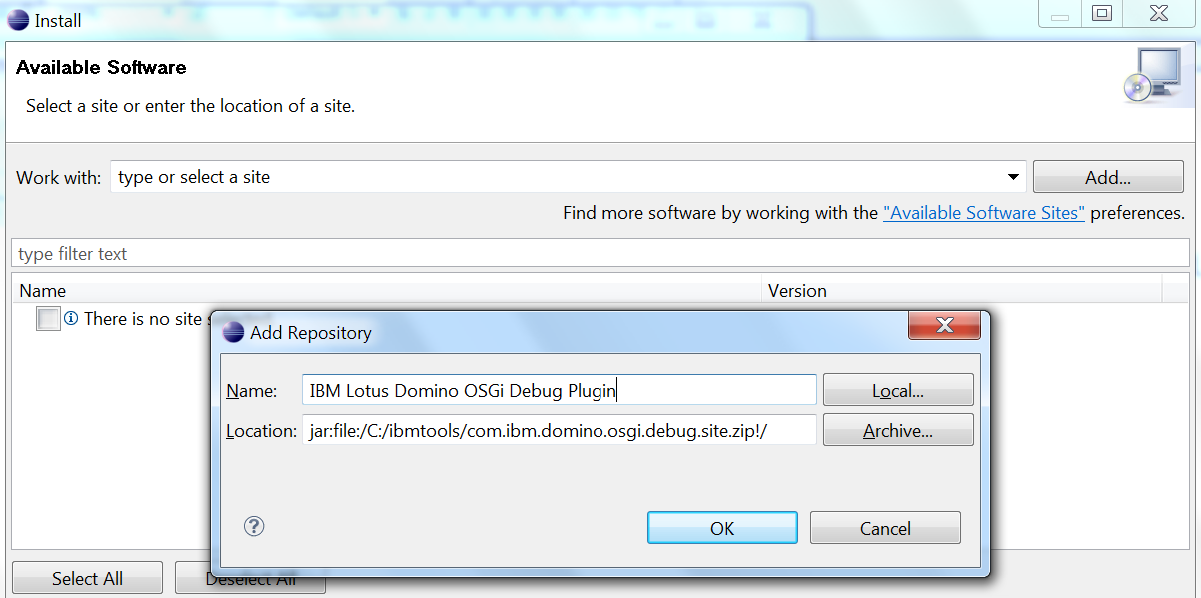

- Click OK, select the IBM Lotus Domino OSGi debug feature from the list

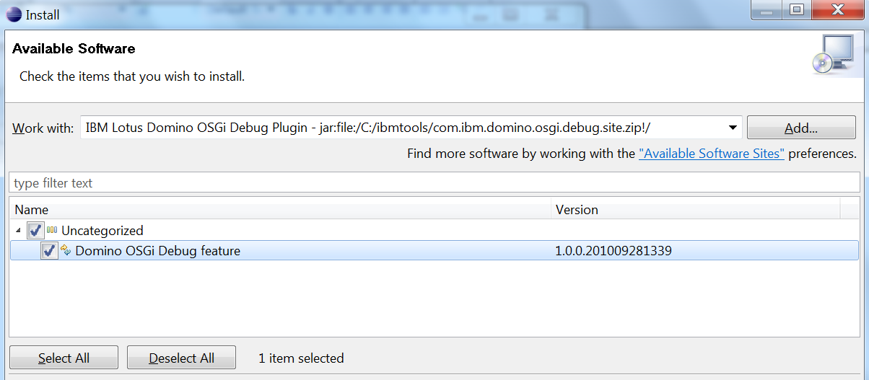
- Click Next and accept the license... (Note, you can find the complete licenses in the licenses directory located in the distro zip)
- Click Finish
- Click Yes to let Eclipse restart. Verify that the tool is correctly installed by using the menu Help\About Eclipse SDK and click on the Installation details button
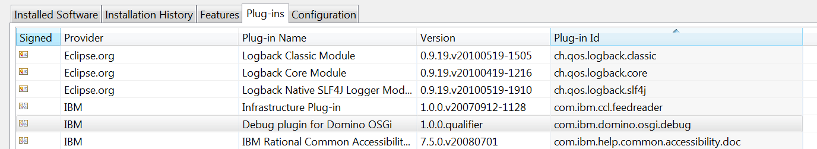

Using the IBM Lotus Domino Debug Plugin:
Setting up the development environment for writing XPages custom controls plugins is out of scope for this document. Please refer to the documentation for the OpenNTF project titled “XPages Extension Library” at the url: “http://extlib.openntf.org”. In particular, refer to the section titled “Installing a development environment for contributing to the library” in the included documentation for this project.
- Create an OSGi debug configuration for IBM Lotus Domino: use menu run\debug configuration, right click on OSGi Configuration entry and select new
- Use the following options:
-Framework combo box: select “Domino OSGi Framework”
-Default Auto-Start: select false
- From the Workspace plugins select the plugins you want to enable. It is recommended to de-select all the plugins in the target platform, the tool will automatically add them from the IBM Lotus Domino Install
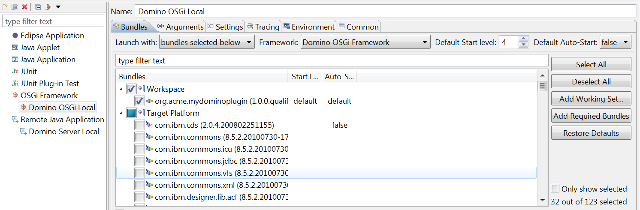
- Click debug, you should see the following dialog box that lets you configure where the IBM Lotus Domino Server is installed.
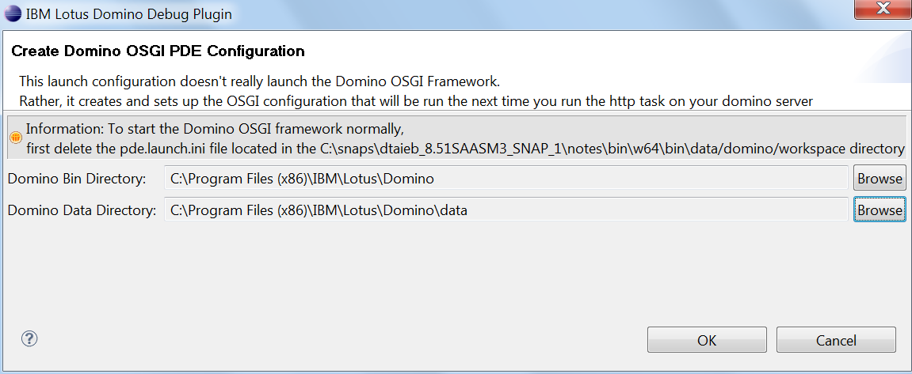
- Click OK, and when successfully completed, you should see the following dialog box.
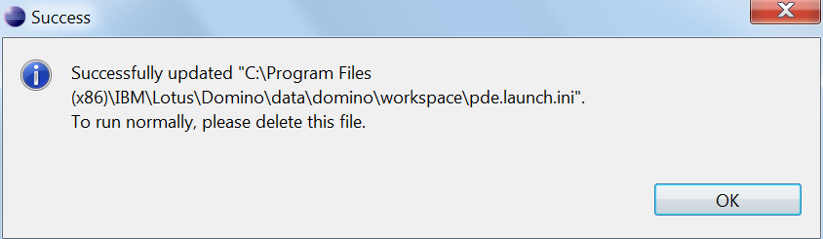
- Next, you need to verify that the plugins are correctly loaded in the IBM Lotus Domino OSGi runtime. In the domino server, restart the http task:
>restart task http
You should see the following extra messages:

- >tell http osgi ss : You should see a list of all the plugins loaded in the runtime
- Assuming that the plugin com.acme.myplugin is a plugin you wanted to load from your workspace, use the following command to verify that it is the case
>tell http osgi diag com.acme.myplugin
You should see the following results:

Debugging your plugin
- Add the following notes.ini variable to start the http task in debug mode:
JavaEnableDebug=1
JavaDebugOptions=transport=dt_socket,server=y,suspend=n,address=8000
- From Eclipse IDE, create a Remove Java debugging configuration
-Run\Debug Configuration, right click on “Remote Java Application” and select New
-Pick a name for the configuration, select localhost for the server name and 8000 for the port:
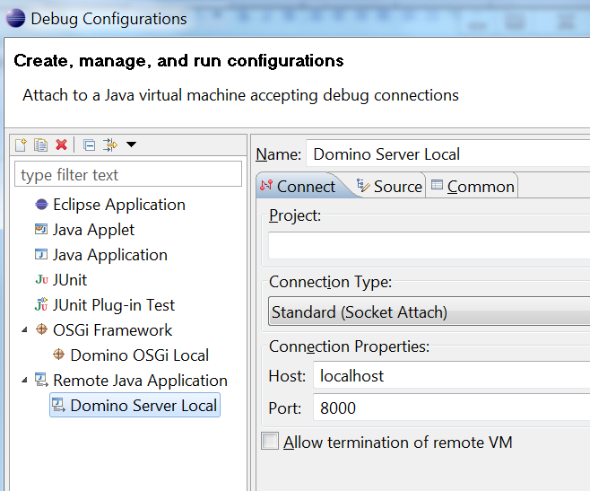
- Click debug, you should be connected to the Domino Http JVM, ready to debug

